E-GAME STORE WEBSITE

191CS55 –WEB TECHNOLOGY LABORATORY

# MINI PROJECT REPORT

Submitted by

# LAKSHMANA PANDIAN.P (2101047)

**DHULASI KUMAR.A (2101028)**

# KIRTHICK SAKTHI.V (2101046) ABIVARSHAN.K(2101004)

*in partial fulfillment for the award of the degree*

of

BACHELOR OF ENGINEERING

**in**

COMPUTER SCIENCE AND ENGINEERING

**P.S.R. ENGINEERING COLLEGE, SIVAKASI – 626140**

(An Autonomous institution, Affiliated to Anna University, Chennai)

# ANNA UNIVERSITY: CHENNAI 600 025

**BONAFIDE CERTIFICATE**

Certified that this project report “ **E-GAME STORE WEBSITE**” is the bonafide work of **LAKSHMANA PANDIAN.P (2101047), DHULASI KUMAR.A (2101028)** and **KIRTHICK SAKTHI.V(2101046),**and **ABIVARSHAN.K (2101004)** who carried

out the project work under my supervision. Certified further, that to the best of my knowledge the work reported herein does not form part of any other project work.

|  |  |
| --- | --- |
| **SIGNATURE**  **Dr. A. RAMATHILAGAM, M.E., Ph.D., HEAD OF THE DEPARMENT**  **Professor,**  Department of CSE,  P.S.R Engineering College, Sivakasi-626140. | **SIGNATURE**  **Ms. G. RENUGA DEVI, M.E.,SUPERVISOR**  **Assistant Professor,**  Department of CSE,  P.S.R Engineering College, Sivakasi-626140. |

Submitted for the Viva -Voce examination held on ……………

**INTERNAL EXAMINER EXTERNAL EXAMINER**

ACKNOWLEDEMENT

We take this opportunity to all those who helped towards successful completion of this mini project. At the very outset we thank the almighty for his profuse blessings showered on us. We thank our beloved parents whose encouragement and support help us to complete our project successfully.

It is our greatest pleasure to convey our thanks to **Thiru R. Solaisamy, Correspondent** and **Director Er. S. vigneswari Arunkumar B. Tech., PSR engineering college, Sivakasi** for providing required facilities and suitable infrastructure to complete our project.

It is our greatest privilege to convey our thanks to **Dr. J. S. Senthilkumaar, M.E., Ph.D., Principal** for continuous support to complete our project without hurdles.

We proud profound gratitude to our beloved Head of the Department **Dr. A. Ramathilagam, M.E., Ph.D., Professor** for providing ample facilities to complete our project successfully.

We also wish to express our sincere thanks to our project Coordinator

**Mrs. J. Amutha, M.E.,** Assistant Professor for having helped us in all aspects.

We also bound to thanks to all Faulty and Non-teaching staff members of The **Department of Computer Science and Engineering** whose support and cooperation also contributed much to complete this project work.

**ABSTRACT**

Epic Games Store is a digital distribution platform for PC games, mods, and DLC. It is owned and operated by Epic Games, Inc. The store offers a wide range of games of every genre, including free games, and supports Unreal Engine. The platform also provides support for game developers to distribute their games on the store. This website enables a user to buy and sell games via network without even visiting the store.

# TABLE OF CONTENTS

|  |  |  |
| --- | --- | --- |
| **S. No** | **CONTENTS** | **PAGE** |
| **1** | **INTRODUCTION** |  |
| **2** | **SYSTEM SPECIFICATION** |  |
| 2.1 | HARDWARE REQUIREMENTS |  |
| 2.2 | SOFTWARE REQUIREMENTS |  |
| **3** | **SOFTWARE DESCRIPTION** |  |
| 3.1 | HARDWARE INTERFACE |  |
| 3.2 | SOFTWARE INTERFACE |  |
| 3.3 | IMPLEMENTATION |  |
| **4** | **METHODOLOGY** |  |
| **5** | **SOURCE CODE** |  |
| **6** | **OUTPUT** |  |
| **7** | **CONCLUSION** |  |

**INTRODUCTION**

An e-game store, often referred to as a digital game store or online game store, is a digital marketplace or platform where users can purchase, download, and play video games and related digital content. These stores are typically accessed through the internet and are used by gamers to acquire video games for various platforms, including PC, gaming consoles, and mobile devices.

E-game stores provide a convenient and centralized platform for distributing video games to players. This accessibility allows gamers to easily discover, purchase, and download games from a wide variety of developers and publishers. Gamers can access a vast library of games without the need for physical copies, making gaming more accessible to a global audience.

Benefits of Email Validation:

* Convenience. ...
* Accessibility ...
* Saves money. ...
* Cloud saves...
* Digital libraries ...
* Wide game selection. ...
* Refund and customer support ...
* Prevents deliverability issues.

# SYSTEM SPECIFICATION

* 1. **HARDWARE REQUIREMENTS:**
     + Processor - Intel Pentium Processor i3
     + RAM – 8 GB is enough
     + System type – 32 bit OS, x64- based processor
  2. **SOFTWARE REQUIREMENTS:**
     + Windows or other equivalent Operating system
     + Notepad and browser

# SOFTWARE DESCRIPTION

* 1. **HARDWARE INTERFACE:**

No Special Hardware Interface Needed Apart From Standard Personal Computer

* 1. **SOFTWARE INTERFACE:**

Applications can be developed using a wide range of programming languages, frameworks, and tools. The choice of technologies depends on the specific requirements of the application, the target platform (web, mobile, desktop, etc.), and the developer's preferences. Here are some common technologies and combinations used in application development.

* 1. **IMPLEMENTATION:**

The implementation phase of software development involves turning the design and plans into a functioning and operational application. It includes writing code, integrating components, and performing various testing and quality assurance activities.

HTML CODE:

HOME:

<!DOCTYPE html>

<html lang="en">

<head>

<meta charset="UTF-8">

<meta name="viewport" content="width=device-width, initial-scale=1.0">

<link rel="stylesheet" href="gamer.css">

<title>Gmaer's Den</title>

</head>

<body>

<nav>

<div class="left">

<div class="left-left"><img src="./photo/Gamer's Den-1 (1).png " style="height: 80px; width: 80px;" alt=""></div>

<div class="left-right">

<li><a href="./gamer.html" class="target">HOME</a></li>

<li><a href="./genre.html">GENRE</a></li>

<li><a href="./about.html">ABOUT</a></li>

</div>

</div>

<div class="right">

<div class="right-left">

<input type="text" placeholder=" SERACH ">

</div>

<div class="right-right">

<img src="./photo/download.jpg" alt="" style="height: 80px; width: 80px; border-radius: 70%;">

</div>

</div>

</nav>

<div class="head">

<h1>BEST SELLERS </h1>

<p>The globally top selling games<br> from the entire industry</p>

</div>

<!-- image -->

<div class="total-img">

<div class="photo">

<a href="./each.html"><img src="./photo/last of us.jpeg" alt=""></a>

<p>Last of us II</p>

<p style="font-size: x-small;">The game take place in a<br> post-apocalyptic world <br>

ravaged by a fungal infection </p>

</div>

<div class="photo">

<a href="./details/god.html"><img src="./photo/god of war.jpeg" alt=""></a>

<p>God of War</p>

<p style="font-size: x-small;">God of War" follows the a<br> journey of Kratos, and his <br>

young son Atreus.</p>

</div>

<div class="photo">

<a href="./details/Seikro.html"><img src="./photo/seikro.jpeg" alt=""></a>

<p>Seikro</p>

<p style="font-size: x-small;">Ancient samurai<br> post-apocalyptic world <br>

ravaged by a fungal infection </p>

</div>

<div class="photo">

<a href="./details/ghost.html"><img src="./photo/ghost.jpeg" alt=""></a>

<p>Ghost of Tsushima</p>

<p style="font-size: x-small;">Play the role of Jin Sakai, who <br> must protect his homeland <br>

from Mongol forces </p>

</div>

</div>

<div class="second">

<div class="new">

<h1>NEWLY RELEASED</h1>

<p>Freshly out of the studio,ready to serve with love and care</p>

</div>

<div class="total-img">

<div class="photo">

<a href="./details/cod.html"><img src="./photo/cod.jpeg" alt=""></a>

<p>COD</p>

<p style="font-size: x-small;">The game take place in a<br> post-apocalyptic world <br>

ravaged by a fungal infection </p>

</div>

<div class="photo">

<a href="./details/miles.html"><img src="./photo/miles.jpeg" alt=""></a>

<p>SPIDERMAN MILES</p>

<p style="font-size: x-small;">The game take place in a<br> post-apocalyptic world <br>

ravaged by a fungal infection </p>

</div>

<div class="photo">

<a href="./details/horizon.html"><img src="./photo/horizon.jpeg" alt=""></a>

<p>HORIZON</p>

<p style="font-size: x-small;">The game take place in a<br> post-apocalyptic world <br>

ravaged by a fungal infection </p>

</div>

<div class="photo">

<a href="./details/red.html"><img src="./photo/red.jpeg" alt=""></a>

<p>RED REDEMPTION</p>

<p style="font-size: x-small;">The game take place in a<br> post-apocalyptic world <br>

ravaged by a fungal infection </p>

</div>

</div>

<div class="middle">

<div class="middle-left"><img src="./photo/elden ring.jpeg" alt=""></div>

<div class="middle-right">

<h1>FREE FOR THE MONTH</h1>

<p> "Elden Ring" is an upcoming action role-playing game developed by FromSoftware in<br>

collaboration with acclaimed author George R.R. Martin, known for his work on the "A<br>

Song of Ice and Fire" series. Set in a vast and mythical world created by Hidetaka<br>

Miyazaki, the creator of the "Dark Souls" series, "Elden Ring" is highly anticipated by<br>

fans of both gaming and fantasy literature.<br>

<br>

<br>

<button id="button-1">Get</button>

</p>

</div>

</div>

</div>

<div class="third">

<div class="head">

<h1>FREE TO PLAY </h1>

<p>Not all entertainment need to <br> cost money, share the fun! </p>

</div>

<!-- image -->

<div class="total-img">

<div class="photo">

<a href="./details/fire.html"><img src="./photo/fire.jpeg" alt=""></a>

<p>FIRE WATCH</p>

<p style="font-size: x-small;">The game take place in a<br> post-apocalyptic world <br>

ravaged by a fungal infection </p>

</div>

<div class="photo">

<a href="./details/forza.html"><img src="./photo/forza.jpeg" alt=""></a>

<p>FORZA</p>

<p style="font-size: x-small;">The game take place in a<br> post-apocalyptic world <br>

ravaged by a fungal infection </p>

</div>

<div class="photo">

<a href="./details/gta.html"><img src="./photo/gta.jpeg" alt=""></a>

<p>GRAND THEIF AUDIO</p>

<p style="font-size: x-small;">The game take place in a<br> post-apocalyptic world <br>

ravaged by a fungal infection </p>

</div>

<div class="photo">

<a href="./details/hollow.html"><img src="./photo/hollow.jpeg" alt=""></a>

<p>HOLLOW KNIGHT</p>

<p style="font-size: x-small;">The game take place in a<br> post-apocalyptic world <br>

ravaged by a fungal infection </p>

</div>

</div>

</div>

<h1 id="line" style="text-align: center; padding: 60px;">"Life is a game. Play it, enjoy it, win it"</h1>

<div class="fourth">

<div class="fourth-first">

<h1 style="padding-left: 270px;">About us</h1>

<p>We proudly stand as the industry s foremost destination for <br> all your gaming needs. Our unwavering commitment to <br>

providing unparalleled customer satisfaction sets us apart<br> as the best in the business. With a meticulously curated<br> selection of games from every genre, our store offers a<br> diverse and extensive catalog that caters to the<br> preferences of every gaming enthusiast.</p>

<div class="photo-2">

<img src="./photo/Gamer's Den-1 (1).png" alt="">

</div>

<h1>Our policy</h1>

<p>Once your order is placed, our dedicated fulfillment team<br> springs into action, carefully packaging your games with<br> utmost care. We work closely with trusted shipping<br> partners to guarantee reliable and secure delivery to your<br> doorstep. Rest assured, we provide real-time tracking<br> information, allowing you to monitor the progress of your<br> shipment every step of the way.</p>

</div>

</div>

</body>

</html>

PURCHASE PAGE:

<!DOCTYPE html>

<html lang="en">

<head>

<meta charset="UTF-8">

<meta name="viewport" content="width=device-width, initial-scale=1.0">

<title>Each</title>

<link rel="stylesheet" href="each.css">

</head>

<body>

<nav>

<div class="left">

<div class="left-left"><img src="./photo/Gamer's Den-1 (1).png" style="height: 80px; width: 80px;" alt=""></div>

<div class="left-right">

<li><a href="./gamer.html" class="target">HOME</a></li>

<li><a href="./genre.html">GENRE</a></li>

<li><a href="./about.html">ABOUT</a></li>

</div>

</div>

<div class="right">

<div class="right-left">

<input type="text" placeholder=" SERACH ">

</div>

<div class="right-right">

<img src="./photo/download.jpg" alt="" style="height: 80px; width: 80px; border-radius: 70%;">

</div>

</div>

</nav>

<div class="top">

<div class="photo">

<img src="./photo/last of us.jpeg" alt="">

Last

<div class="line">

<h1>THE LAST OF US - PART II</h1>

<h3>Survival - Adventure - Action</h3>

<pre>Continuing the story of Ellie and Joel from the first game, "The

of Us Part II" takes place in a post-apocalyptic world ravaged by a fungal infection that turns humans into vicious creatures. Ellie, now a young woman, sets out on a journey of vengeance against a group that has committed a heinous act</pre>

<br>

<br>

<br>

</div>

<div class="side">

<h2>Developers:Naughty Dog</h2>

<h2>Price: 899/-</h2>

</div>

</div>

</div>

<div class="head">

<h1>SCREENSHOTS</h1>

</div>

<div class="total-img">

<div class="photo-2">

<img src="./photo/hunt.jpeg" alt="">

</div>

<div class="photo-2">

<img src="./photo/maankutty.jpeg" alt="">

</div>

<div class="photo-2">

<img src="./photo/back.jpeg" alt="">

</div>

</div>

<hr class="hr">

<div class="head">

<h1>SIMILAR GAMES </h1>

</div>

<div class="total-img-2">

<div class="photo">

<img src="./photo/last of us 2.jpeg" alt="">

<p>Last of us II</p>

<p style="font-size: x-small;">The game take place in a<br> post-apocalyptic world <br>

ravaged by a fungal infection </p>

</div>

<div class="photo">

<img src="./photo/ghost.jpeg" alt="">

<p>Ghost</p>

<p style="font-size: x-small;">The game take place in a<br> post-apocalyptic world <br>

ravaged by a fungal infection </p>

</div>

<div class="photo">

<img src="./photo/dying.jpeg" alt="">

<p>Dying</p>

<p style="font-size: x-small;">The game take place in a<br> post-apocalyptic world <br>

ravaged by a fungal infection </p>

</div>

<div class="photo">

<img src="./photo/tomb.jpeg" alt="">

<p>Tomb Raiders</p>

<p style="font-size: x-small;">The game take place in a<br> post-apocalyptic world <br>

ravaged by a fungal infection </p>

</div>

</div>

</body>

</html>

<!DOCTYPE html>

<html>

<head>

<title>Gamer's Den - About</title>

<style>

/* Define the styles for the about page */ body {

font-family: Arial, sans-serif; background-color: #F0F0F0; padding: 20px;

}

h1 {

text-align: center; color: #333333;

}

p {

margin-bottom: 20px;

}

.container {

max-width: 600px; margin: 0 auto;

}

.logo {

display: block; margin: 0 auto; width: 200px;

}

</style>

</head>

<body>

<div class="container">

<h1>About Our Game</h1>

<img src="./photo/Gamer's Den-1 (1).png" alt="Game Logo" class="logo" style="background-color: black;">

<p>

Welcome to our game website! Here, you can find exciting and entertaining games for all ages.

</p>

<h2>About the Game</h2>

<p>

Our game is an immersive experience that takes you on an adventure through a virtual world.

It offers stunning graphics, captivating gameplay, and a variety of challenges to keep you engaged for hours.

</p>

<h2>Features</h2>

<ul>

<li>High-quality graphics and sound effects</li>

<li>Multiple levels and game modes</li>

<li>Leaderboards to compete with friends</li>

<li>Intuitive controls for seamless gameplay</li>

<li>Regular updates with new content</li>

</ul>

<h2>Contact Us</h2>

<p>

If you have any questions, feedback, or issues regarding our game, please feel free to contact us.

We value your input and are always here to assist you.

</p>

<p>Email: [info@example.com](mailto:info@example.com)</p>

<p>Phone: +1234567890</p>

</div>

</body>

</html> ABOUT PAGE:

<!DOCTYPE html>

<html lang="en">

<head>

<meta charset="UTF-8">

<meta name="viewport" content="width=device-width, initial-scale=1.0">

<link rel="stylesheet" href="genre.css">

<title>Genre</title>

</head>

<body>

<nav>

<div class="left">

<div class="left-left"><img src="./photo/Gamer's Den-1 (1).png " style="height: 80px; width: 80px;" alt=""></div>

<div class="left-right">

<li><a href="./gamer.html" class="target">HOME</a></li>

<li><a href="./gamer.html">GENRE</a></li>

<li><a href="./about.html">ABOUT</a></li>

</div>

</div>

<div class="right">

<div class="right-left">

<input type="text" placeholder=" SERACH ">

</div>

<div class="right-right">

<img src="./photo/download.jpg" alt="" style="height: 80px; width: 80px; border-radius: 70%;">

</div>

</div>

</nav>

<div class="first">

<div class="first-top">

<div class="content">

<h1>OPEN WORLD</h1>

<p style="font-size:small;">Search the best of Action games available in the gaming industry.

Its all blood, guns, swords and fights here.</p>

</div>

<div class="photo">

<a href="./details/red.html"><img src="./photo/red.jpeg" alt=""></a>

<p>RED REDEMPTION</p>

<p style="font-size: x-small;">The game take place in a<br> post-apocalyptic world <br>

ravaged by a fungal infection </p>

</div>

<div class="photo">

<a href="./details/gta.html"><img src="./photo/gta.jpeg" alt=""></a>

<p>GTA</p>

<p style="font-size: x-small;">The game take place in a<br> post-apocalyptic world <br>

ravaged by a fungal infection </p>

</div>

<div class="photo">

<a href="./details/miles.html"><img src="./photo/miles.jpeg" alt=""></a>

<p>Spiderman Miles</p>

<p style="font-size: x-small;">The game take place in a<br> post-apocalyptic world <br>

ravaged by a fungal infection </p>

</div>

</div>

</div>

<div class="second">

<div class="first-top">

<div class="photo">

<a href="./details/Seikro.html"><img src="./photo/seikro.jpeg" alt=""></a>

<p>Seikro</p>

<p style="font-size: x-small;">The game take place in a<br> post-apocalyptic world <br>

ravaged by a fungal infection </p>

</div>

<div class="photo">

<a href="./details/ghost.html"><img src="./photo/ghost.jpeg" alt=""></a>

<p>Ghost</p>

<p style="font-size: x-small;">The game take place in a<br> post-apocalyptic world <br>

ravaged by a fungal infection </p>

</div>

<div class="photo">

<a href="./details/cod.html"><img src="./photo/cod.jpeg" alt=""></a>

<p>COD</p>

<p style="font-size: x-small;">The game take place in a<br> post-apocalyptic world <br>

ravaged by a fungal infection </p>

</div>

<div class="content">

<h1>ACTION</h1>

<p style="font-size:small;">Search the best of Action games available in the gaming industry.

Its all blood, guns, swords and fights here.</p>

</div>

</div>

</div>

<div class="third">

<div class="first-top">

<div class="content">

<h1>SURVIVAL</h1>

<p style="font-size:small;">Search the best of Action games available in the gaming industry.

Its all blood, guns, swords and fights here.</p>

</div>

<div class="photo">

<a href="./each.html"><img src="./photo/last of us 2.jpeg" alt=""></a>

<p>Last of us II</p>

<p style="font-size: x-small;">The game take place in a<br> post-apocalyptic world <br>

ravaged by a fungal infection </p>

</div>

<div class="photo">

<a href="./details/horizon.html"><img src="./photo/horizon.jpeg" alt=""></a>

<p>HORIZON</p>

<p style="font-size: x-small;">The game take place in a<br> post-apocalyptic world <br>

ravaged by a fungal infection </p>

</div>

<div class="photo">

<a href="./details/god.html"><img src="./photo/god of war.jpeg" alt=""></a>

<p>God of War</p>

<p style="font-size: x-small;">The game take place in a<br> post-apocalyptic world <br>

ravaged by a fungal infection </p>

</div>

</div>

</div>

</body>

</html>

WEBSITE DESIGN:

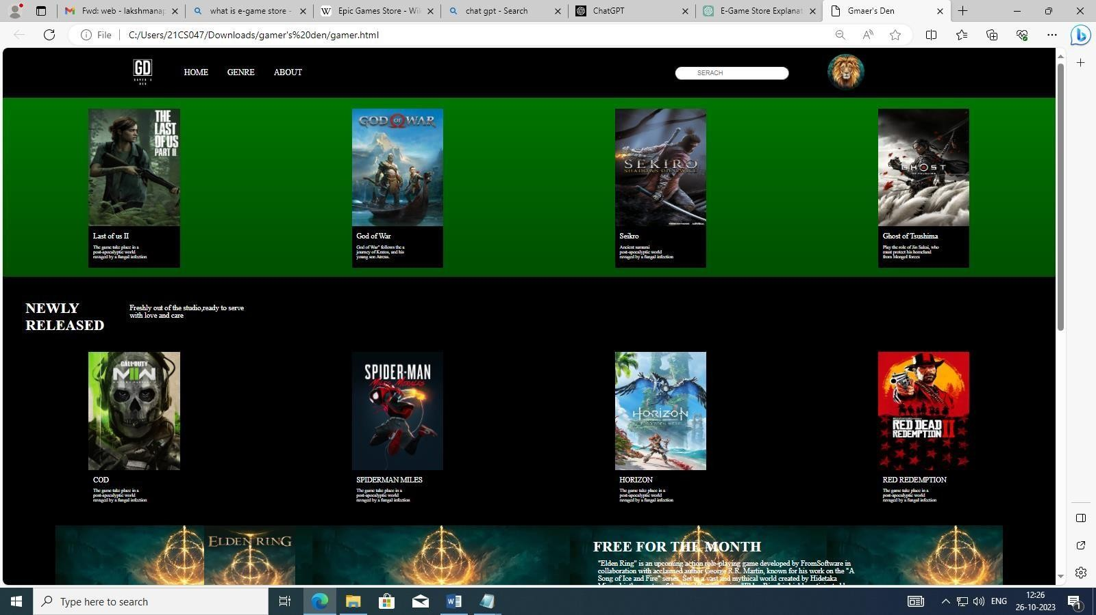

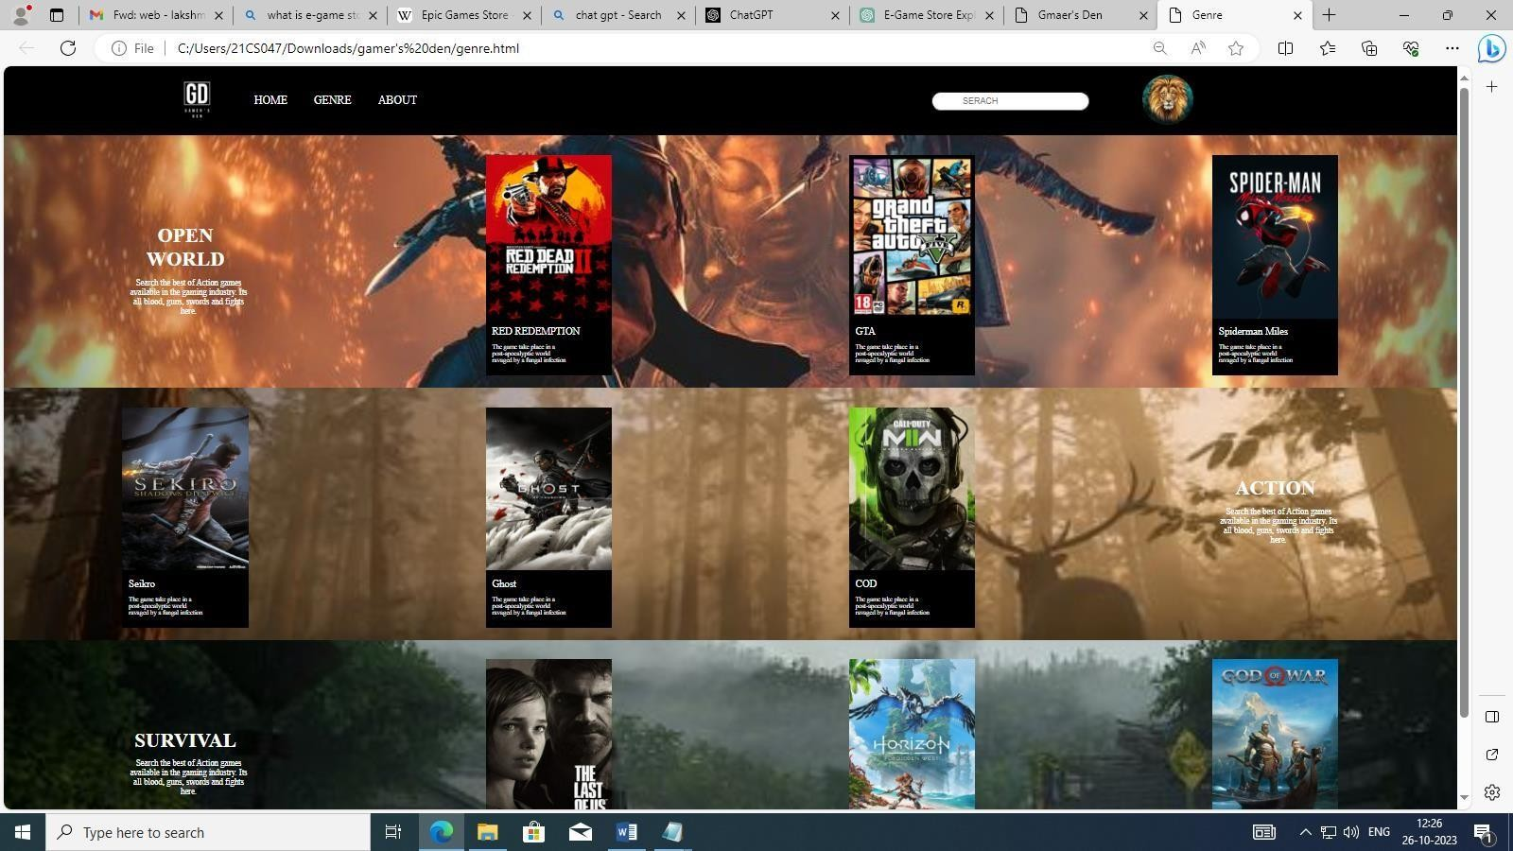

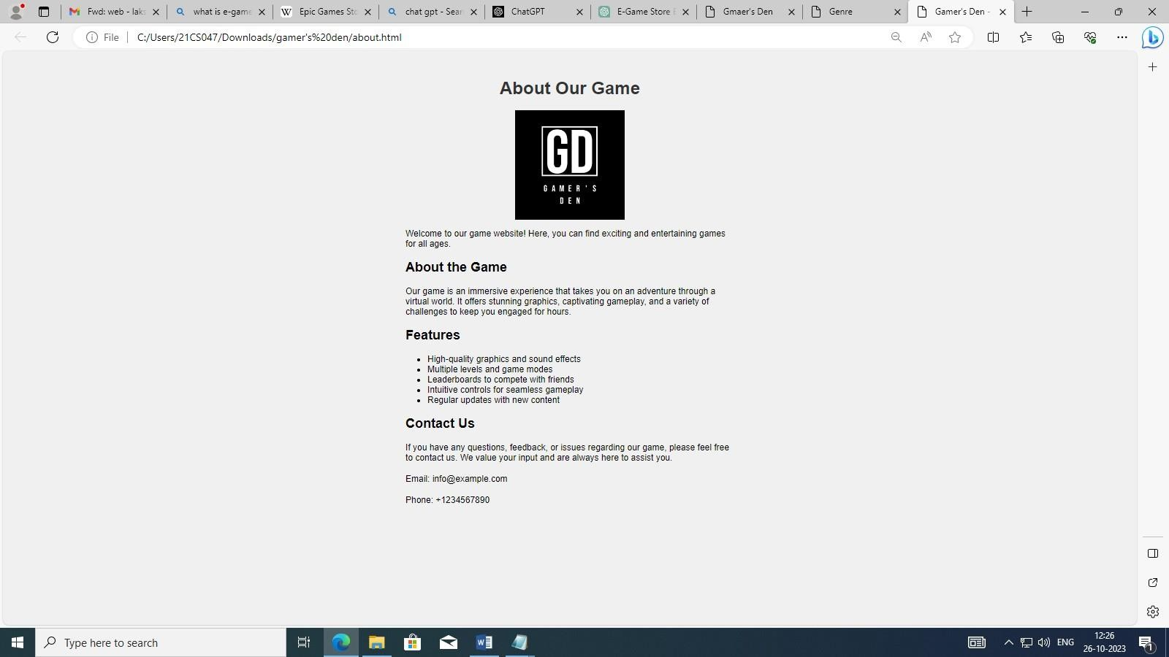

CONCLUSION:

Thus in conclusion, E-game stores has significant potential

and promise that provide gamers with the convenience of downloading games directly to their devices. This eliminates the need to visit physical stores, wait for shipping, or handle physical game discs.